**MONARE MOSEHLE ST10101825 PROG6212 PART 1**

**REPORT**

The Contract Monthly Claim System (CMCS) is made to make easy the submission and approval of monthly claims for Independent Contractor (IC) lectures. The main goal is clarity a simple role base interface for Lectures, Program Coordinators, and Academic Managers that support claim submission, doc upload, status tracking, and admin approval workflows. I choose ASP.NET Core WPF to use strong C# tools in Visual Studio and make future work easy like separating views, controllers, models and also unit test.

Database design focus on normalized data that can be check later. Main things is User (role base), Claim, ClaimItem, Document, and Approval. Claim keeps main info like lecture, month, totalHours, totalAmount, status, submissionDate. ClaimItem keeps line info like hours, rate and amount. Document link upload file to claim and keep file name and date. Approval saves each approval action with time and comments. We assume rate is per lecture per claim saved in ClaimItem, file is stored outside on server or cloud and only link in Document, security and login will use ASP.NET Identity later. Limitations is offline filing not needed, and GUI prototype is only for look not working.

GUI layout is small dashboard and easy claim form. Lecture view has New Claim button, Claim Form with month picker and ClaimItem rows with description, hours, rate and amount. There is also file upload box and Submit button. Coordinator and Manager view have list of claims with filters like Pending, Approved, Rejected. Claim detail panel shows docs preview and buttons for approval or reject with comment box. Status badge show progress Submitted → CoordinatorAproved → ManagerAproved → Settled. UI will have clear nav, tables that fit, and feedback like badges and popups. It also needs good fonts, labels and keyboard control.

Version control has 5 git commits (start project, add UML and docs, add GUI mockup, styling fix, final report). Things to give is Word report, UML diagram, project plan, GUI mockup, and GitHub link.

**PROJECT PLAN**

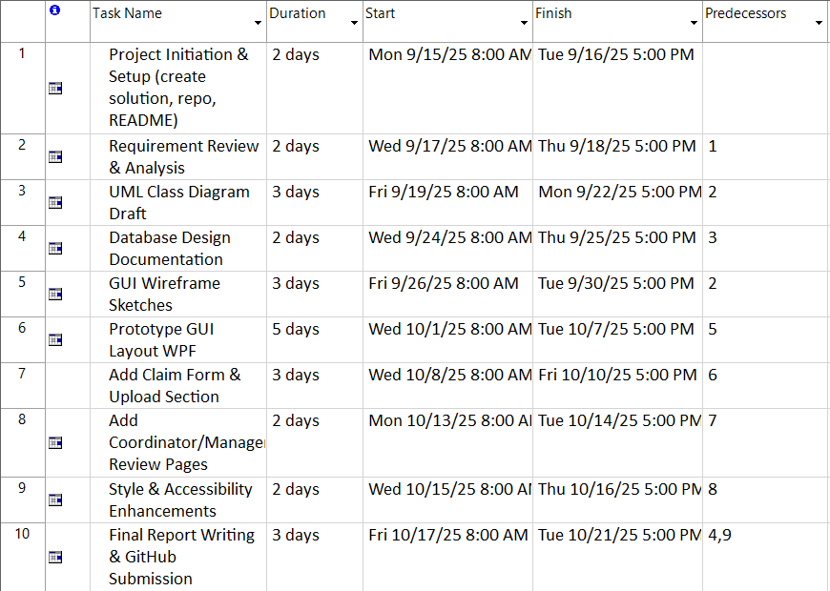

**GANTT CHART**

**NETWORK DIAGRAM**

**UML DIAGRAM**

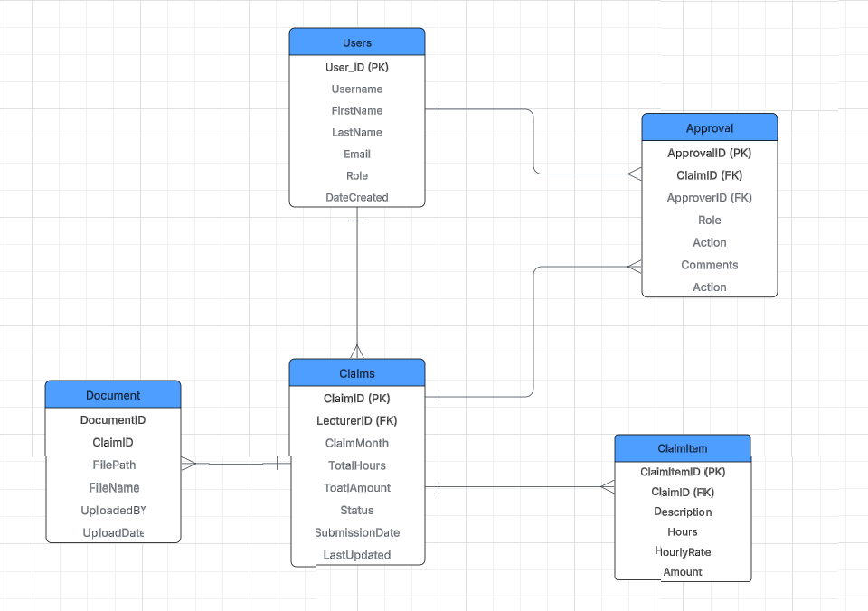

**FRONTEND AND BACKEND CODE**

Coordinator Dashboard

Main Window

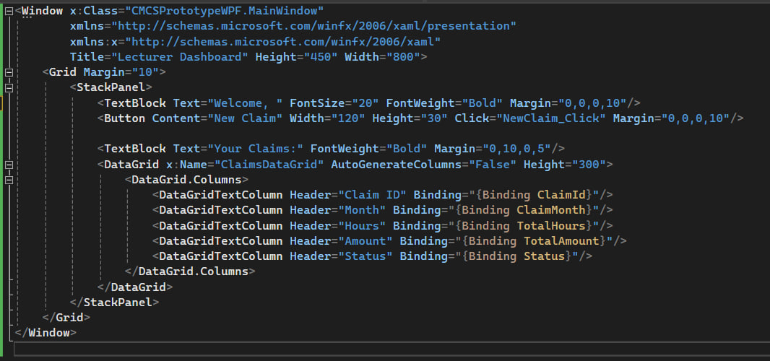

New Claim Window

